Title: | <Door Control Module>  SW Component < DIO >

History
Issue status  (Index) | Maturity/Date  (draft/invalid/valid)  (dd-mmm-yyyy) | Author  Department | Check/Release  Department | Description
1.0 | Draft  04-0ct-20 | Miguel Garcia | Miguel Garcia | Creation of the document

Table of Contents
1 Purpose 3
2 Definitions and abbreviations 3
3 Realization constraints and targets 3
4 SW Conceptual design 3
5 SW Component internal breakdown 4
5.1 Functional Decomposition 4
5.2 Function <Type> <function name> (type par 1, .., type par n) 5
5.3 Function <Type> <function name> (type par 1, .., type par n) 5

Purpose
This document has been created to show how the DIO system works in the Door Module Control project. The DIO system means Digital Input/Output, this part will receive multiple digital signals to process them and will return digital values (1/0, HIGH/LOW).

Definitions and abbreviations
Definitions
Special Byte  DCM  CAN  DIO  HIGH  LOW | Special byte received to change the baud rate 55h  Door Control module  CAN protocol  Digital Input/Outputs  Digital signal, equals to 1  Digital signal, equals to 0

Abbreviations
DCM Door control Module
DIO Digital Input/Outputs
J0 Jumper 0
J1 Jumper 1
References
N° | Document name |  | Reference
1  2  3 | Door Control Module.doc  SWA_DCU.rpyx  Traceability Matrix template.xlsx

Realization constraints and targets
Transmitting digital signals effectively to all the system, such as read inputs and return digital values (outputs) to perform actuations inside the DCM.
As an obstacle, we have a difficult to read inputs clearly, since we’ll need to make a filter to reduce the noise in the DIO input process. On the other hand, we have the digital outputs, this part will no need some extra process to add.

SW Conceptual design
To make a conceptual design identify the product functions and the programs parts needed to produce them.
- Identify all relevant parts in a system or sub-system.
- Define which parts are inside & outside the system boundary
- Define de interfaces between these parts, but also interfaces with neighboring systems and environment.
- Describe the global data and the interfaces in order to interact with it.

SW Component internal breakdown
DIO SW component is composed of 3 main functions, all of them receive and return digital values (1/0):

- DIO_Init
- DIO_Read (include all the microcontroller’s ports)
- DIO_Write (include all the statements of the signals in the microcontroller.)

This function even need a interface (SIGNALS) that receives and transmit signals via CAN. This signals come from DOOR, WINDOW, BUTTON, HW_CONFIG.

DATA TYPES
Values
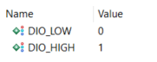

Functional Decomposition
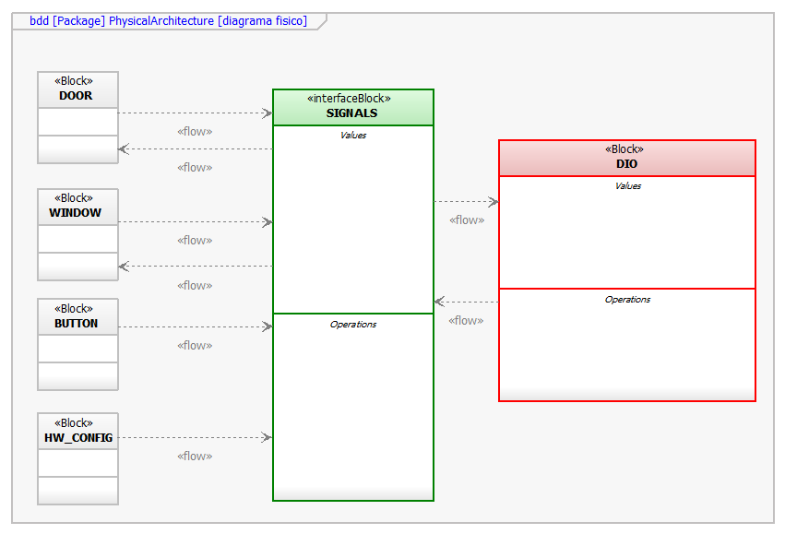
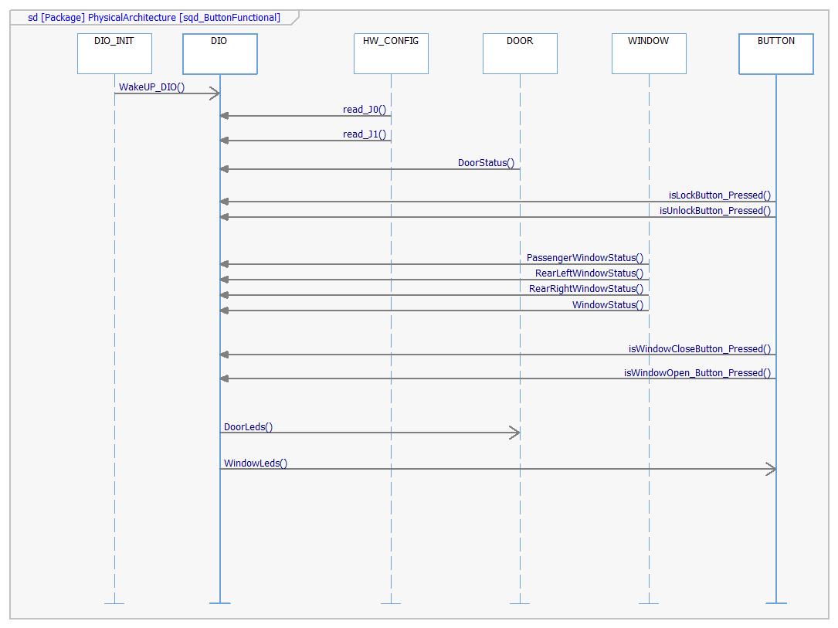

Function Description
DIO system uses SIGNAL as interface to communicate with the rest of architecture (DOOR, WINDOW, BUTTON & HW_CONFIG systems). HW_CONFIG will send the software version (reading J0 and J1); Button just send the status of all the physical buttons (WINDOW_UP, WINDOW_DOWN, LOCK_BUTTON, UNLOCK_BUTTON…) there’s no need to return a message or actuation, because is just a reding function to DIO system. Window send the status of all the car’s windows (passenger_window, rearRight_window, rearLeft_window and driver_window); DOOR send the status of the car’s doors (lock or unlock). After all the process of reading status, the DIO will return a 10 bits signal to WINDOW, each bit turn on its correspondent led (bit 1 => Window_led1, bit 2=> Window_led2… bit 10=Window_led10), also will return a 2 bits signal to DOOR, each bit turn on its correspondent led (bit 1 => DoorLock_led, bit 2=> DoorUnlock_led).

Function uint_8 SW_VERSION (bool J0, bool J1)
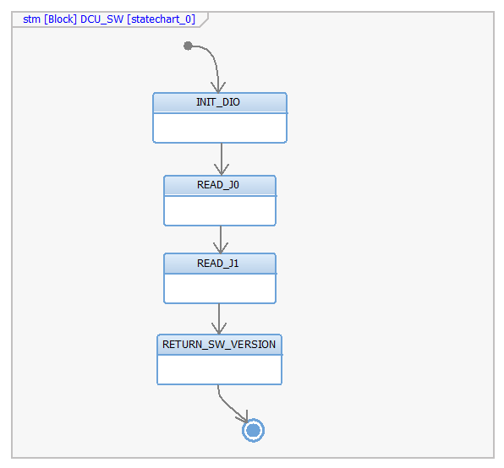

Description | This function return the software version (1, 2, 3 or 4)
bool J0  <input> | This parameter is the result of read J0 (true = 1, false = 0)
bool J1  <input> | This parameter is the result of read J1 (true = 1, false = 0)
Return Value | This function will return the software version, just 4 combinations are possible
Precondition | This function is just called once (at the beginning) in the program lifetime
Post condition | This function can’t be called again once is finished
Error Conditions | J0 & J1 are not between 1 or 0
Requirements | DCU_SWR_152

Dynamic Behavior

bool J0=true;
bool J1=true;

expected result:
SW_VERSION=4;

Function void DoorLeds (bool isLockButton_Pressed, bool isUnlockButton_Pressed, bool DoorState)
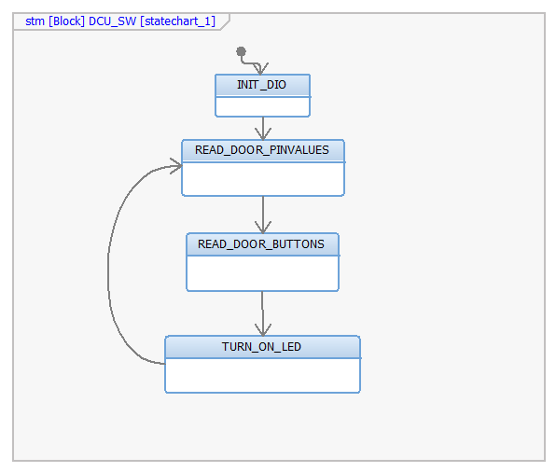

Description | This function will activate or deactivate each door led. For buttons, 1 = pressed and 0 = not pressed. For DoorState, 1 = locked, 0 = unlcoked
Bool isLockButton_Pressed  <input> | Input parameter, to know if Lock Button is pressed or not
Bool isUnlockButton_Pressed  <input> | Input parameter, to know if Unock Button is pressed or not
Bool DoorState  <input> | Receive the door statement (is locked or unlocked)
Return Value | No value to return
Precondition | Both buttons are not pressed, SW_Error is not detected
Post condition | Clear SW_Error
Error Conditions | Both buttons are pressed.
Requirements | DCU_SWR_117, DCU_SWR_118, DCU_SWR_119, DCU_SWR_137, DCU_SWR_138, DCU_SWR_139, DCU_SWR_141, DCU_SWR_142

Dynamic Behavior
bool isLockButton_Pressed=false;
bool isUnlockButton_Pressed=true;
bool DoorState=true;
Expected result:
DoorLed turn into green.

bool isLockButton_Pressed=true;
bool isUnlockButton_Pressed=true;
bool DoorState=true;
expected result:
SW_Error();

Function void WindowLeds (bool window_button, bool RearLeftWindow_button, bool RearRightWindow_button, bool PassengerWindow_button )
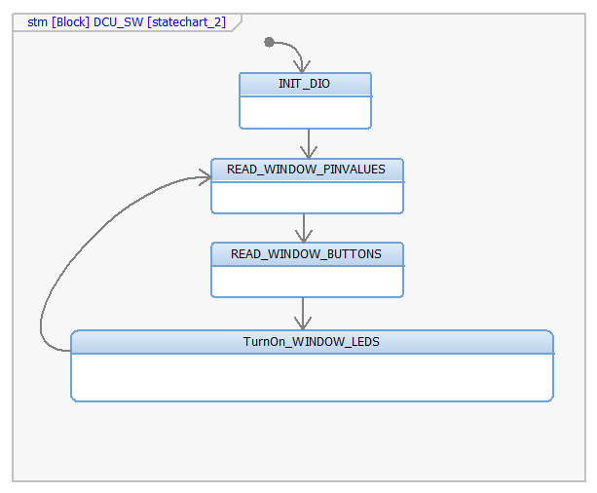

Description | This function will activate or deactivate each window led actuation.
Bool window_button  <input> | Input parameter, to know if driver window button is pressed and its sense
Bool RearLeftWindow_Button  <input> | Input parameter, to know if rear left window button is pressed and its sense
Bool RearRightwindow_Button  <input> | Input parameter, to know if rear right window button is pressed and its sense
Bool PassengerWindow_button  <input> | Input parameter, to know if drir window button is pressed and its sense
Return Value | No value to return
Precondition | SW_Error is not detected
Post condition | Clear SW_Error
Error Conditions | Both buttons are pressed
Requirements | DCU_SWR_1, DCU_SWR_10, DCU_SWR_100, DCU_SWR_101, DCU_SWR_102, DCU_SWR_103, DCU_SWR_104, DCU_SWR_105, DCU_SWR_106, DCU_SWR_11, DCU_SWR_110, DCU_SWR_111, DCU_SWR_112, DCU_SWR_113, DCU_SWR_114, DCU_SWR_115, DCU_SWR_116

Dynamic Behavior

This function will activate the 10 windows leds. The DIO system will send a 10 bits signal and each one of them will activate its correspondent led

uint_16 signal;
signal[0]=activate_led1();
signal[1]=activate_led2();
…
…
…
signal[9]=activate_led10();

